Our Logo: 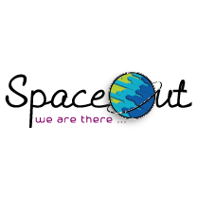

Slogan : We Are There

About us :

SpaceOut is an out of the box Digital Marketing Agency, in which we provide creative and efficient ways for our clients to meet their needs. We value the concept of "Making a difference through social media”, as we take great pride in our client's progress and growth and our work with them.

Mission:

We believe that the strategy and content we provide can capture and embrace our audience and rise our client's business.

Services:

1-Social Media:

Strategy set up, Visuals, Content Creation , Data Analysis , Reporting

2-Production:

Online Videos , Motion Videos , TV Ads

3-Branding kit and Printing :

Logo , Corporate Identity , Flyers , Brochure , Rollup

Clients:

1-Lama Rejuvenation Clinic 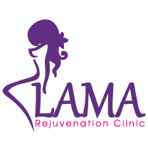

2-Dr. Abram 

3- Dr.Ashraf Badawi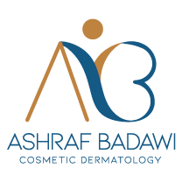

4-Fabrika 

5-Power Grass 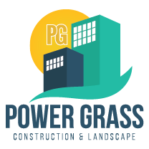

6-Abano Di Parma :

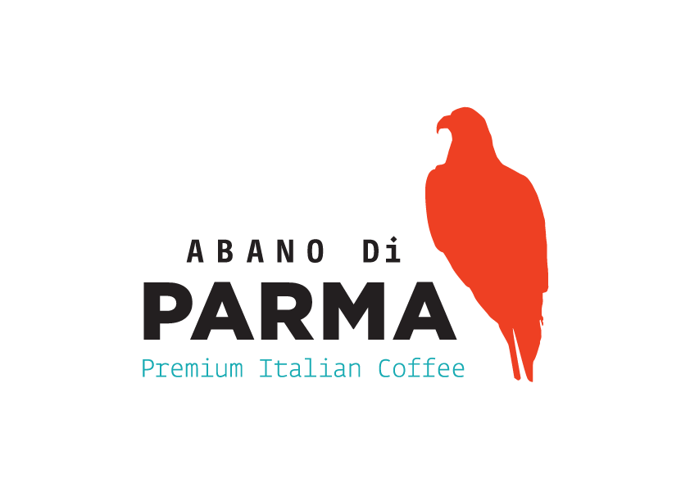

Get in touch :

Spaceout ( Facebook – LinkedIn – Instagram )

Location : 98 El Shabab Street , El Sheikh Zayed , Giza , Egypt

Phone number : 01005781010 – 01008930888

(Insert created email here )